ExcelToRazl Script Generator

Bas Wiebing – 09-08-2016

Table of Contents

Introduction 3

Requirements 3

Installation 3

Generating a Razl script 4

Creating the Excel 4

Setting up the tool – generate the script 5

Run a Razl XML Script 6

# Introduction

The ExcelToRazl script generator has been developed to be able to convert an Excel file to a Razl script XML file. When you have to maintain a Sitecore DTAP environment it may happen that content managers test content on different stages. When they do so and keep track of the items which are being changed in Excel, this tool provides you the functionality to automatically generate and run a Razl script form that very Excel.

## Requirements

To be able to generate a XML Razl script file, the following requirements will have to be met:

* [.Net framework 4.5](https://www.microsoft.com/nl-nl/download/details.aspx?id=30653) installed on your system
* Access to the source stage Sitecore instance (for example: Sitecore test instance)
* When using itempaths in the Excel, you’ll also need to enable the Sitecore Item Web API or the Sitecore Service Client

To be able to run a XML Razl script file, the following requirements will have to be met:

* [Hedgehog Razl](http://www.razl.net/download.aspx) has been installed on your system (this tool is tested with Razl version V3.0.4).
* You have already setup a source and target connection in Razl.

## Installation

To start working with the tool, just unzip the file package and run the ExcelToRazl.exe file. No further installation will be necessary.

# Generating a Razl script

In this chapter will be explained how you can generate a Razl script using the ExcelToRazl script generator.

## Creating the Excel

For generating a Razl script file, you first need an Excel file with information on which items are to be included into the script. The Excel file will need to have the following columns:

* Type – *Simple copy one of these two choices to this field:*
  + “CopyAll” – *Copies the item and all of its children*
  + “CopyItem” – *Only copies the item*
* ItemPath or ItemId – *The Sitecore item path or item id of the item which has to be copied*
* Overwrite – *Only needs to be filled when type is “CopyAll”, set it to “TRUE” or “FALSE”:*
  + “TRUE” – *Overwrite existing items*
  + “FALSE” – *Merge with existing items*

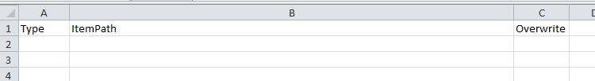

Figure 1 – Excel file with ItemPath example

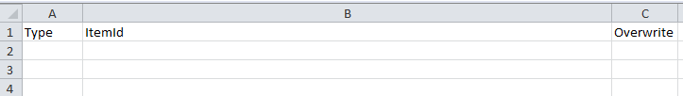

Figure 2 – Excel file with ItemId example



Figure 3 – Example Excel file with content

An example Excel file is available within the ExcelToRazl installation zip file: *Razl.xlsx*.

## Setting up the tool – generate the script

When you open Razl.exe, the following screen will appear:

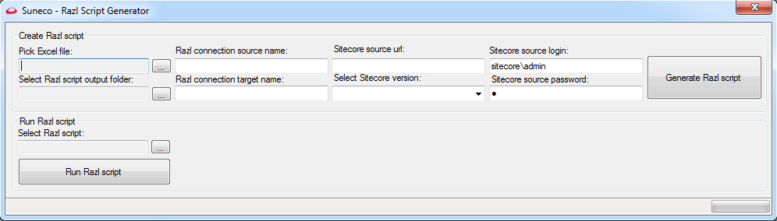

Figure 4 - Razl Script Generator screen

To Generate a Razl script, fill in the fields in the “Create Razl script” section.

* Pick Excel file – *Open the Excel file which contains the ItemPaths or ItemIds.*
* Select Razl script output folder – *Select a folder in which the Razl script XML file will be stored.*
* Razl connection source name – *Insert a connection name which has been setup in Razl:*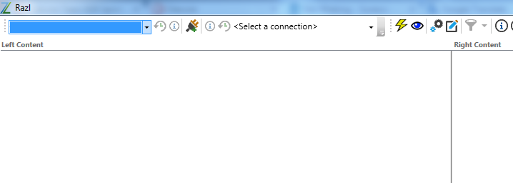
* Razl connection target name – *Insert a connection name which has been setup in Razl:*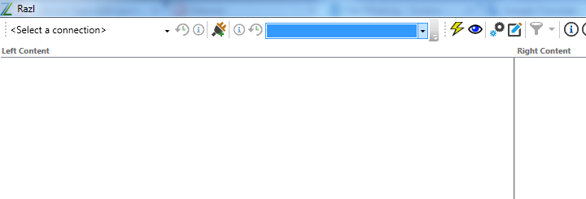
* Sitecore source url – *Fill in the hostname of your Sitecore instance running the Item Web API or the Sitecore Service Client.*
* Select Sitecore version – *To determine if we need to make calls to the Item Web API or to the Sitecore Service Client, we need you to specify which version is running on your Sitecore instance.*
* Sitecore source login – *Enter your username (“domain\username”) to access the Sitecore source instance. Default Sitecore admin login is “sitecore\admin”.*
* Sitecore source password - *Enter your password to access the Sitecore source instance. Default Sitecore admin login is known to you.*

When all fields are set you can hit the button “Generate Razl script” and the XML file will be generated and saved in the Razl script output folder.

# Run a Razl XML Script

To run a Razl XML script Hedgehog Razl needs to be installed on your system. This section is unavailable when Razl is not installed.

Please refer to *Figure 4 - Razl Script Generator screen*.

In the “Run Razl script” section simply select a (generated) Razl XML script and run it by clicking the “Run Razl script” button. The tool will search your system for the Razl.exe file and uses it to run the XML script.